Annual General Meeting Agenda

Tuesday, April 30th, 2024 @ 4:00-6:00 PM

Virtual: Microsoft Teams

Agenda

1. Welcome and Call to Order

6. Acknowledgement of Indigenous Territory 3

7. Previous Meeting Minutes 4

8. Executive Reports 5

9. Communications 6

10. Old Business 7

a. Updates 7

11. New Business 8

a. Item 8

12. Adjournment 8

# Welcome and Call to Order

When quorum is met, the chair will welcome attendees and call the meeting to order, noting the time in the minutes.

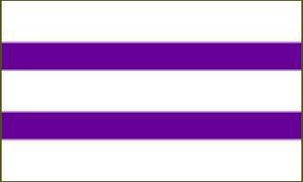

# Acknowledgement of Indigenous Territory

On behalf of the Brock Chapter of Golden Key, I would like to begin by acknowledging and honouring the ancestors of those on whose traditional lands we gather today. Brock University is located on the traditional beaver hunting grounds; a shared territory of the Anishnaabe (Aw-nishi-naw-bay), Haudenosaunee (Haw-den-ohshow-nee), and other nations. Today, we welcome and acknowledge all Indigenous Peoples who have joined us including First Nation, Métis, and Inuit, and we also welcome members of settler society.

# Previous Meeting Minutes

[insert minutes]

# Executive Reports

Possible motion: to accept reports by omnibus.

[insert reports]

# Communications

# Old Business

## Updates

# New Business

## Item

Possible motion: …

# Adjournment